* LDR (Light Dependent Resistor) :-

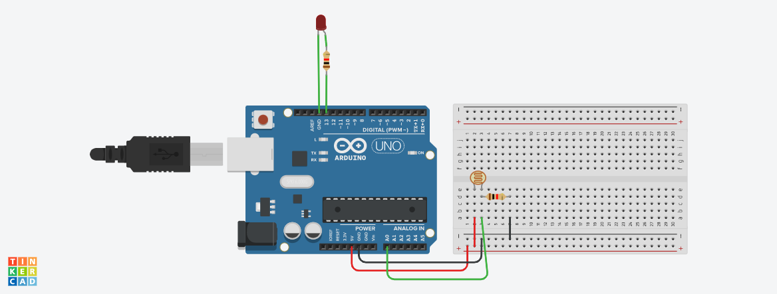

**Circuit diagram**

* **Description :-**

This project is on LDR sensor. LDR is a component that has a (variable) resistance that changes with the light intensity that falls upon it. LDR is also known as **Photo resistors.**

* **Application :-**

Street light, light intensity meter, alarm clock, smoke detector etc.

* **Working Principle:-**

This photo resistor works on the principle of photo conductivity. It is nothing but, when the light falls on its surface. Then the material conductivity reduces and also the electrons in the valence band. These photons in the incident light must have energy greater than the band gap of the semiconductor material. This makes the electrons to jump from the valence band to conduction.

* **Circuit Connection :-**

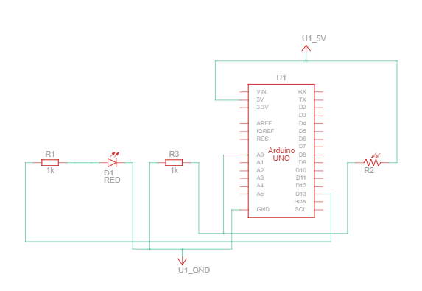

* **Basic working :-**

These devices depend on the light, when light falls on the LDR then the resistance decreases, and increases in the dark. When a LDR is kept in the dark place, its resistance is high and, when the LDR is kept in the light its resistance will decrease.

* Component List :-

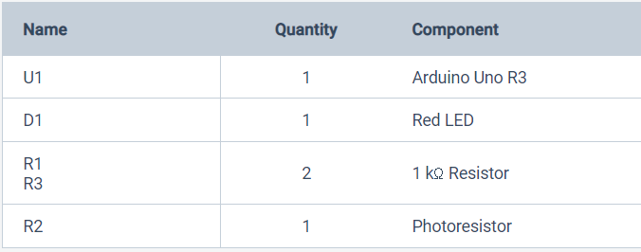

* **CODES :-**

// C++ code

//

int LDR = 0;

void setup()

{

pinMode(A0, INPUT);

Serial.begin(9600);

pinMode(13, OUTPUT);

}

void loop()

{

LDR = analogRead(A0);

Serial.println(LDR);

if (LDR > 500) {

digitalWrite(13, HIGH);

delay(1000); // Wait for 1000 millisecond(s)

} else {

digitalWrite(13, LOW);

delay(1000); // Wait for 1000 millisecond(s)

}

}